1.Enter a sample input: 16,22,13, 19,11, -1 for the following experiment.

**PROGRAM**

## #include<stdio.h>

## int main(void)

## {

## int k, smallest;

## printf("Enter integers, when");

## printf(" done enter a ");

## printf("negative number\n");

## scanf_s("%d", &k, 1);

## // assign the first number to smallest variable

## smallest = k;

## // iterate while k >= 0

## for( ; k >= 0; )

## {

## // if the entered number is < smallest

## if(k < smallest)

## {

## // then assign the number to smallest variable...

## smallest = k;

## // do some checking...

## printf("The smallest number has just been changed to %d\n", smallest);

## }

## // read the next input....repeat

## scanf_s("%d", &k, 1);

## }

## // print the smallest number...

## printf("The smallest number is %d\n", smallest);

## return 0;

}

**FLOWCHART**

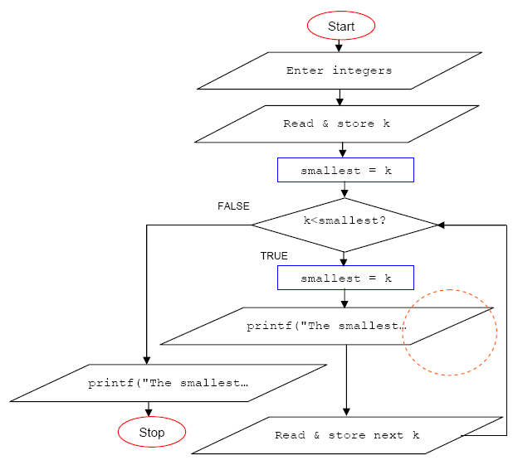

## **2.Enter a sample input: 16,22,13, 19,11, -1 for the following experiment. The program will determine the smallest number entered.**

## 

## **PROGRAM**

## #include<stdio.h>

## int main(void)

## {

## int i, k, smallest, item_num;

## printf("Enter sample integers, negative integer when done\n");

## scanf_s("%d", &k, 1);

## // assign the first input to variable smallest

## smallest = k;

## // initialize the item_num to 1

## item_num = 1;

## // start the for loop

## for(i = 1; k >= 0; i = i + 1)

## {

## // if the entered number is < smallest...

## if(k < smallest)

## {

## // assign the entered number to smallest

## smallest = k;

## // assign the count to item_num...

## item_num = i;

## }

## // read next input...repeat

## scanf_s("%d", &k, 1);

## }

## // print the result...

## printf("The smallest number was %d\n", smallest);

## printf("and it was data item number %d\n", item_num);

## return 0;

## }

FLOWCHART

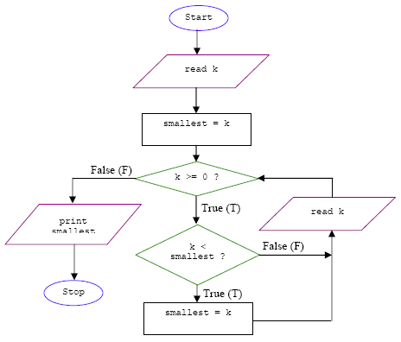

**3.Use a sample input: 16,22,13, 19,11 and -1 for the following experiment. This program will determine the smallest and the largest numbers entered.**

**PROGRAM**

 #include<stdio.h>

## int main(void)

## {

## int k, smallest, largest;

## printf("Enter sample integers, negative integer when done\n");

## scanf_s("%d", &k, 1);

## // assign the first input to variable smallest and largest

## smallest = k;

## largest = k;

## // start the for loop

## for( ; k >= 0; )

## {

## // if the entered number is < smallest...

## if(k < smallest)

## // assign the entered number to smallest

## smallest = k;

## // if the entered number is > largest...

## if(k > largest)

## // assign the entered number to largest

## largest = k;

## // read next input...repeat

## scanf_s("%d", &k, 1);

## }

## // print the result...

## printf("The smallest number was %d\n", smallest);

## printf("The largest number was %d\n", largest);

## return 0;

## }

**FLOWCHART**

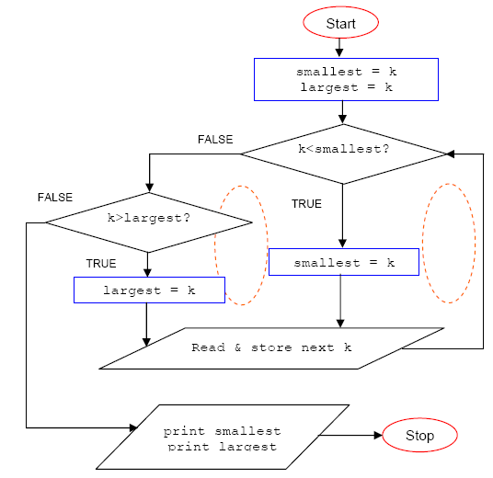

**4.Next, let try using abreak command. Run the following program twice. For the first run, use 10 positive integers, for the second, use 5,12, 7,2 and -3.**

**PROGRAM**

## #include<stdio.h>

## int main(void)

## {

## int i, k, sum = 0, flag = 0;

## printf("Enter 10 sample integers, negative integer when done\n");

## for(i = 1; i <= 10; i = i + 1)

## {

## scanf_s("%d", &k, 1);

## // if k < 0...

## if(k < 0)

## {

## flag = 1;

## // break the loop...

## break;

## }

## // for k > 0, do the sum and repeat...

## sum = sum + k;

## }

## if(flag == 1)

## printf("Unacceptable data.\n");

## else

## printf("Sum = %d\n", sum);

## return 0;

## }

**FLOWCHART**

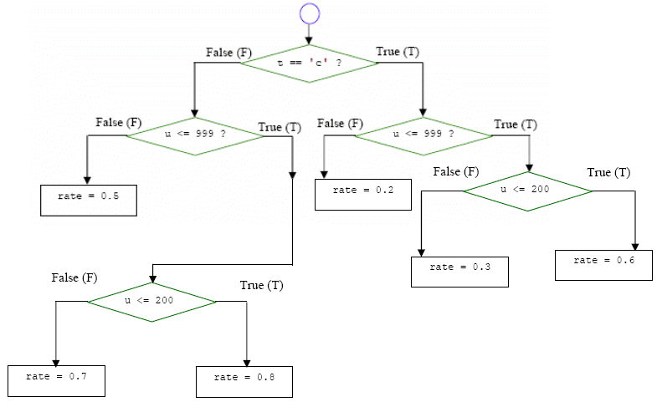

**5.The largest is 16, 13 and 11 and the smallest is 16 and 22. You can see this by adding some codes as shown below.**

**PROGRAM**

#include <stdio.h>

int main(void)

{

  int k, smallest, largest;

  printf("Enter sample integers, negative integer when done\n");

  scanf_s("%d", &k, 1);

  // assign the first input to variable smallest and largest

  smallest = k;

  largest = k;

  // start the for loop

  for( ; k >= 0; )

  {

    printf("smallest:%d, largest:%d pos1\n", smallest, largest);

    // if the entered number is < smallest...

    if(k < smallest)

    // assign the entered number to smallest

    smallest = k;

    if(k > largest)

    largest = k;

    // read next input...repeat

    printf("smallest:%d, largest:%d pos2\n", smallest,    largest);

    scanf_s("%d", &k, 1);

}

// print the result...

printf("smallest:%d, largest:%d pos3\n", smallest, largest);

printf("The smallest number was %d\n", smallest);

printf("The largest number was %d\n", largest);

return 0;

}

